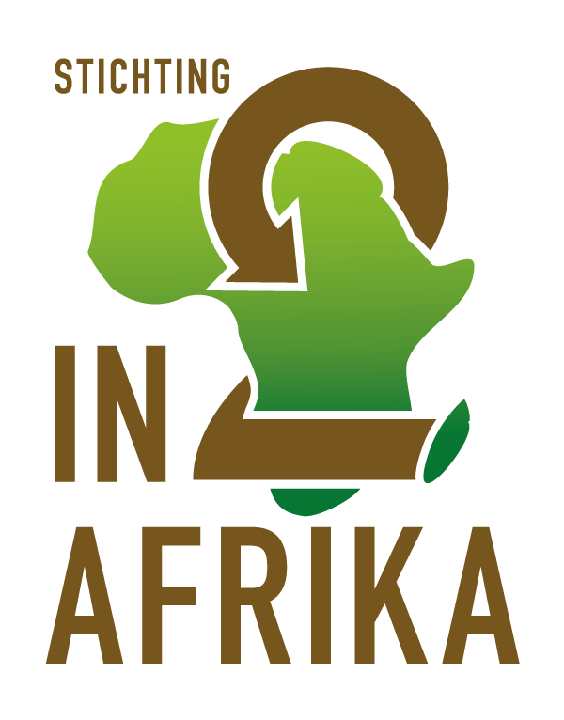

Policy plan

Last update: March 2016

Jesse Oberdorf, chairman/secretary
Vincent Oberdorf, Treasurer
In2Afrika Foundation
www.in2afrika.nl

Summary
In front of you is the policy plan of the In2Afrika foundation. In2Afrika is a foundation created by two brothers: Jesse Oberdorf (chairman-secretary), and Vincent Oberdorf (treasurer). From February to June 2015 In2Afrika traveled through 11 different countries, from North to South on the African continent. On this trip we visited a selection of development projects that we want to highlight and support.
In preparation for this trip, a selection was made of small-scale projects who, independently, each in its own way, want to develop his or her environment, and with that let the African continent as a whole make a step forward. The projects vary content wise, from humanitarian work to scientific development, from sports to education. In our view, these civil society projects are the core of the development of the African continent.
The main goal of foundation In2Afrika is twofold. Firstly, we want to offer being a partner for the projects and customized our support to the work that they do, work which we believe in. This support may include the exchange of knowledge and expertise, linking the projects to a similar organization in the Netherlands, generating publicity or financial contribution.
In addition to the support we want to provide, and therefore strongly connected, we also strive to change the negative image of the African continent. Because we believe that support for Africa's development goes hand in hand with the improvement of the image the continent has, the foundation has made it her goal to have a positive impact Africa’s general perception as well.
After vision, values, mission and goals we will set out the strategy of our foundation both for the support- as for the imaging part in this policy plan. Finally, with goals there should also be means, and the recruitment, utilization and management of these resources within the foundation are explained in the last paragraph.

The In2Afrika foundation wishes you a pleasant reading!

On behalf of the board of In2Afrika,

Vincent Oberdorf, treasurer.
Index

Preface …………………………………………………………………………………………………………………………… 4
Vision & Core Values ………………………………………………………………………………………………………. 5
Mission & Goals ……….…………………………………………………………………………………………………… 8
Strategy ………………………………………………………………………………………………………………………….. 9
Strategy Support …………………………………………………………………………………………. 9
Strategie Imaging ………………………………………………………………………………………… 10
Means ………………………………………………………………………………………………………………………. 11
After the journey…………………………………………………………………………………………………………… 14

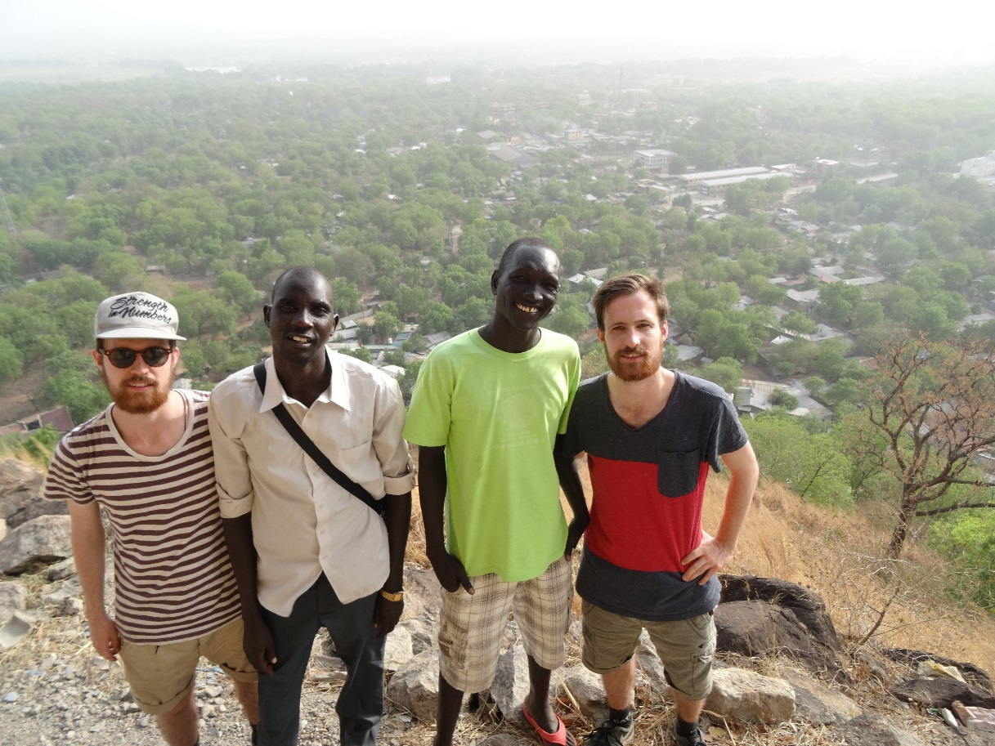

Preface
Africa, a continent on fire. A lost continent. Civil war, ebola and terror. That's Africa. Or could there be more?
Perceptions and awareness on the African continent currently is in a very negative trend in our Western society. Negative, but especially one-sided pictures about Africa predominate in the way our perception of the continent is created. Without being blind to the issues at stake, we are convinced that we need to change this biased perception of the African continent.
In 2013 we decided to get involved. Realizing that we are in a unique position in the Netherlands to reach out a helping hand towards other parts of the world, we want to contribute to the circumstances in which this actually happens. The - often incorrect and incomplete - taboos, fear and chilliness around the African continent are an obstacle to the support that we can provide to a continent to develop. In our vision a proper, honest image of the African continent contributes the desired support we can offer development areas.
To make a change in the image of the African continent, and at the same time actively contribute to the development of this continent, we have started In2Afrika, at the end of 2014. In2Afrika is a foundation that wants to change the image of Africa, and who in addition wants to contribute actively to the independent development of the continent.
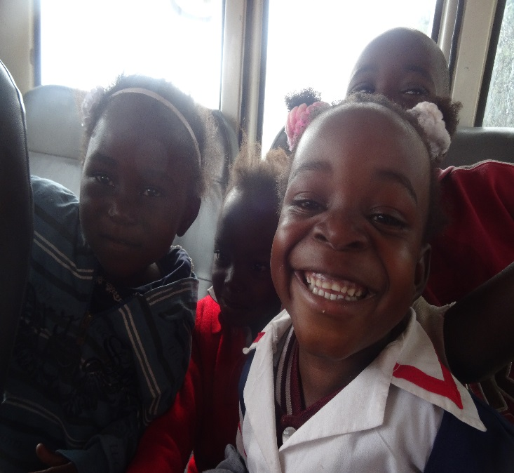
Under vision we focus on our ideas and beliefs, and how we want to put these into practice. We then propose our specific mission and the subsequent objectives of the foundation. The section strategy defines how we will pursue our goals in practice. Finally you will find the section on the resources available to our foundation, and how they were recruited, will be managed and spent.

Vision & Core Values
Africa is a continent on which more than 90% of the states can be characterized as 'developing democracy'. The pursuit of development is a complex puzzle composed of many small pieces. We believe that most of this puzzle must be placed by the residents of the specific areas themselves: it could decide how they want their neighborhood, their community, their country and that of their children and grandchildren will look like.
At the same time we cannot deny that we live in a world where there is an unevenly distribution of development at this time. Where some places have wealth in abundance, other areas are severely short. The reasons for this are at least as complex as the puzzle of development, but In2Afrika looks ahead. We focus on the puzzle of the future. In2afrika believes that, since this development is so unevenly distributed, we must construct part of the puzzle together. Think of it as the corners of the flat-edged pieces from the side. These foundations are required for the final completion of the puzzle. And when a local community needs support with this, In2Afrika tries to offer them. This is the support which In2Afrika works with.
Independent development, with support
What we believe in is that eventually every community should carry its own weight to develop an independent, stable society. In addition, we rely entirely on the vision of the projects we support, to decide how they want to improve their lives. What is undeniable at the same time is that democracies in development, and specifically communities therein need help with taking steps in the right direction. Often there is a 'missing link' which is necessary for a next step in the development, not directly available to these communities. In2Afrika wants to provide this supporting role by assisting in the most small-scale basic form of democratic development, called 'civil society'. More on this below.
Imaging as a challenge
What we observe, however, specifically for the African continent, is an obstacle to the exercise of this supporting role, and therefore in the development of the continent. In the western world a stigmatizing certain image prevails about the African continent, a negative construct of stereotypes glued together. The default image that we summarize in the introduction as "a continent on fire, a lost continent, civil war, ebola and terror," is a picture which we faced constantly in the run-up to this project, and unfortunately still are facing. The Western image of Africa is extremely negative, and in our view this is the supporting role that we can offer the continent in a way. If we want to contribute to the support of a community, in our view a multilateral, informed and positive image of the continent, its countries, population and issues is of great importance. It is the basis for cooperation.
The conclusion we draw for ourselves is that, if that we cannot only provide the required support to assist in the development of African communities from the Netherlands, but we will at the same time have to tackle the standardized image that exists about the African continent. When people do not truly believe in the potential, in the desire to get ahead, development will never be fully believed and embraced. Imaging and support herein therefore go hand in hand. The negative perception that exists around the African continent constitutes a restriction on the provision of support. A complex construct of media, history, education, etc. plays a decisive role in this. In2Afrika sees it as one of her tasks, as a prerequisite for successful development support, to contribute to the image change around the African continent. A realistic, multi-sided, diverse and plural understanding of Africa in all its diversity will have a major contribution to the provision of effective, appropriate support in the development of the communities within the continent.
This duality of entangled, mutually dependent elements is where our foundation focuses on from its vision: Support and Imaging.

civil Society
In the introduction we started with the premise that a state can only develop into a stable democracy, if they carry their own weight in the right direction. In this view-point has the term 'civil society' has come back in several cases. We believe that the civil society is the core of any state that wants to make this transition, and thus the point where we can provide support. Civil society is a collection of organizations, movements and individuals that exist in the space between government, the market and the household. It is a collection of independent, large or small, strong formal or informal loosely organized groups of people who work together to achieve a particular goal or serve interest. In addition to a number of known major Non-Governmental Organisations (NGOs), the civil society consists of many small-scale initiatives where people unite, cooperate, exchange knowledge and resources to eventually achieve a common goal. This civil society, which consists of thousands of different groups, in our view the core of the development of communities, and thus the place where our support is to be used.
In the next section we will work out what specific mission and objectives emerge from this vision.
Empowerment
The second, and with civil society coincident principle on which our vision is based, is empowerment. Within civil society many people and communities organize to commit themselves to development, for a better environment and future. Although these people may very well decide what should be the future, they sometimes lack certain capacities or resources to actually realize this. Empowerment means that In2Afrika tries so to support these people and projects in a way that makes that what was missing in order to achieve development is provided. So we do not determine what the future should be, but bring people into a better, more decisive-position to actually own this future. This makes people and communities independent, and their future sustainable.
Core Values
The vision of our foundation translates into several core values, which have been numerated below:
# 1 Imaging: changing the negative stigma that now rules the image of the African continent.
# 2 Inspire: the bridge between perception and support.
# 3 Activation: reach people and let them participate actively in the process of changing imaging and / or support.
# 4 Support: provide tailored support to selected projects to move forward with their own vision.
# 5 Small scale: small-scale, local initiatives based on appropriate development of African communities. With this we reflect the diversity within the continent, within countries and within communities.
# 6 Empowerment: support (and no interpretation) to activate their own power.
# 7 Independence: we don’t fill in anything for projects, but only support to achieve their self-determined goals, without them having to depend on us
# 8 Sustainability: support and development are focused on the long run. Communities and their environment have to develop structurally and independently.
Mission and Goals
From this vision shows that our mission is bilateral, and one part of our mission cannot be accomplished without the other. Imaging and support are mutually dependent. Therefore, both are intertwined in our mission.
In2Afrika Foundation sees as its mission:
to provide customized support to its selected, small-scale development projects across the African continent and thereby, as inseparable condition of this support, to influence the Western image of Africa positively.
From this mission, the foundation has derived two main objectives:
a) Support: Supporting the development of the African continent through support to small-scale initiatives as the birthplace of a strong civil society.
b) Imaging: As a condition to support change and multilateral application to the negative, especially one-sided image of the African continent, as a basis for proper and adequate support of communities in development.
From this dual mission, we have derived a number of specific sub-objectives, which we pursue with the In2Afrika foundation.
Objective 1: Select, visit and support small African initiatives
Objective 2: Provide support which may include financial resources, sharing of knowledge and expertise, linkage with Dutch partners and / or providing publicity.
Objective 3: Stimulate the African civil society;
Objective 4: Changing the negative, one-sided trend in the image of the African continent
Objective 5: Change of this image of Africa by exposing and reporting on its people and its civil society through our eyes.
Objective 6: Inspire people in the Netherlands and activate them with respect to (the development of) Africa.
How do we want to achieve these objectives will be more fully explained in our strategy.

Strategy
In this paragraph In2Afrika will display its objectives in a more detailed manner. As these objectives can be summarized under the binary with on the one hand Support on on the other hand Imagery, this binary will be the way in which the elaboration upon our strategy will be structured.

Strategy Support
Our first main objective is offering customized support for the projects that we are partnering with. As these projects have very diverse specialisations, it is important to separately examine where exactly our support is most needed for every project. Both in the prelude of our travels as during the time we visited all the projects, we took an extended period of time to speak with the founders of the projects as well as with the main subjects of the project’s interventions. This, to assess what has been going well, and what are the current challenges the community and the project are facing. Based on our findings on the ground In2Afrika decides, in co-creation with the projects, what type of support is needed most. Does the project for example need specific expertise or a financial stimulus to make new investments?
To be able to offer this support, means are necessary (for more in-depth insight in this, see our ‘Means’ paragraph). These means are created by addressing the network of our foundation. Private partners and organisations are approached to participate in or support a project, for example by offering knowledge and expertise. Moreover, this network is used to create a solid financial base for our work. Our income is generated from three specific types of actions: general promotion, general actions and specific actions.
Financial means are thus gathered by a mix of specific and general actions. This means that on the one hand we gather funding both for the foundation and the projects in general. In more detail on can think of fundraising events, 1 on 1 relationships with private donors and spontaneous donations from supporters. On the other hand we do fundraising for specific projects as they come up with a specific need. This means that we appeal to a specific target-group to help us raise funds for a specific project, or to help us find a specific type of expertise. In this, partner-organisations are closely collaborated with.
The last part of the process is use the gathered means in line with the insights and policies of the foundation. We do not just divide financial capital among the projects equally, but look for specific aims and ways to invest in specific needs. For this purpose, we use the insights we have gathered during our local assessment of the projects. In July of 2015 we published a ‘Letter of Intent’ in which we explained the way we divided the financial means of the foundation.
Strategy Imagery
The ultimate aim of our strategy is to create a mindshift through alternative imagery than the currently prominent, popular image that are spread about Africa. We want to do this by reaching as many people as possible with our experiences during our journey along all our different projects, but moreover with general news from the continent. Without closing our eyes for problems and challenges the continent is facing, we want to create an alternative image by showing how many people are trying to improve the life of them and their communities on a daily basis. This way, the popular image of Africa becomes less one-sided.
Although our ultimate aim is to actively engage people, the primary aim is to simply reach people with this alternative message. Popular imagery can only be changed by contrasting it with alternative images that contradict the negative stereotypes that exist about Africa at the moment. This message, and the different images that go along with it, is spread through several channels. For this aim In2Afrika has also created a promotion-plan.
Of course we use digital channels and social media. In2Afrika has a website that is moreover linked to a facebook page. According to us these are the most appropriate fora for our strategy, as these are some of the most widespread channels of spreading images and content through the general public. These channels enable us to share interviews, video’s, pictures and our message on Africa in spoken and written word. Through these digital platforms our alternative image of Africa will be created, as a basis for creating a mindshift. The website is accessible via www.in2afrika.nl, the facebook is named ‘Stichting In2Afrika’.
The different events etc. that are organized for the purpose of fundraising or awareness raising are ideal to actively spread our message. The publicity these events and actions generate will be linked to our digital platforms, enabling the creation of an alternative image to ultimately activating a mindshift. Moreover, partner organisations, sponsors and other media will be used to get our message across.
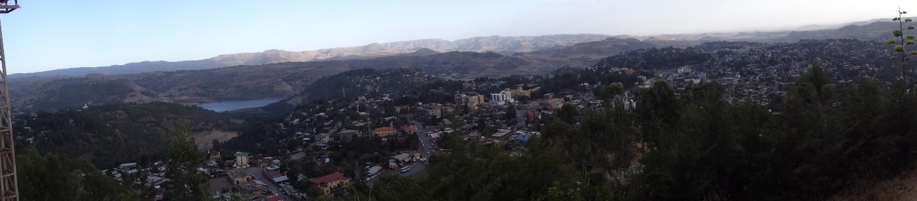

Means
Foundation’s expenditures and covering these expenditures

The expenditures of the foundation can be categorised in different types.
Firstly there are some general expenditures to maintain the foundation and our imagery. These expenditures are summarized under the paragraph of ‘facilitation expenditures’. Besides this, expenditures are made in supporting the different projects. These are covered under the paragraph ‘donations’. Per category we will elaborate on how we cover these expenditures below.

- Facilitation expenditures
As the board of the foundation we want as much of our financial means to end up with our projects. However, we need some of our finances to cover certain costs that come along with running a foundation and doing the work we do. These are side issues, but they are essential in making it possible to ultimately support our projects in the best way possible. Some of these facilitating expenditures are:
- The cost of establishing the foundation (notary costs) and the cost of maintaining our finances (banking);
- The cost of hosting and maintaining the website;
- The cost of promotion and fundraising (through promoting the foundation towards our sponsors and partners and in specific actions for raising funds)

- Establishing the foundation
We have worked hard to cover the cost of founding our foundation with a sponsor. Ultimately, the notary office of Metis from Gulpen was willing to do most of the notary work for free. Cost in financing are mostly banking costs, for example in transferring money to foreigh accounts (of the projects).

- Domain and website
For this specific type of costs, the board of the foundation has decided to invest some private capital of the board members into the foundation. This way, most of the costs that do not fall under the category of ‘donations’ are covered. The board members have transferred this onto the account of the foundation, and will add an investment in necessary. This way it is guaranteed that as much of our funds as possible are used for supporting the projects.

- Promotion costs
Cost made in promoting the foundation among our target group, for example at partners or during events. Moreover, these are costs made with actions specifically aimed at raising funds for the foundation. Costs are always outweighed by the benefits of these actions.

- Donations

One of the ways of supporting the projects is the specific placement of donations for a specific purpose within the project, to enable a project to make a next step in its development. A case-to-case approach that looks closely at the specific needs of every project. Together with the project we decide its specific needs in advance, but mostly through our assessment during visiting the project on the ground. With our Letter of Intent we have published a document in which the way in which we believe our funds should be divided, is explained in more detail.

The income from which these donations to the projects are financed is gathered in different types of ways. In the preparation of our travels we have gathered funding in several different ways:

- General promotion of the foundation and moreover the possibility to make general donation. Both online as during reallife events and gatherings.
- By means of general actions, generating income for the foundation but not for a specific project. For example the In2afrika calender.
- By means of specific actions, aimed at raising funds for a specific project. For example the In2Afrika party at FC Geleen-Zuid, that is partnering with the Arusha Future Stars Academy in Tanzania.

Conclusion
By spliting our expenditures in facilitating expenditures and donations, In2Afrika has created a very clear and transparent situation. De facto, not 90% (required by the Dutch tax authority) but 100% of our budget is spent for the main mission of our foundation. This way In2Afrika has created a clear financial policy to match the expectations that go along with the ANBI-status the Dutch tax administration has granted us.

How does the foundation maintain its capital?
First and foremost we have opened a business account at Rabobank. Our treasurer controls our finances, maintaining an up-to-date administration. The budget of the foundation will be limited to the donations that are made to the projects, with a small amount of extra capital for facilitating expenditures. This way, the foundation as a legal entity has the function of a vehicle transferring raised financial means to the projects that fit into our philosophy. This almost 1 on 1 relationship between income and expenditures creates a very transparent situation.

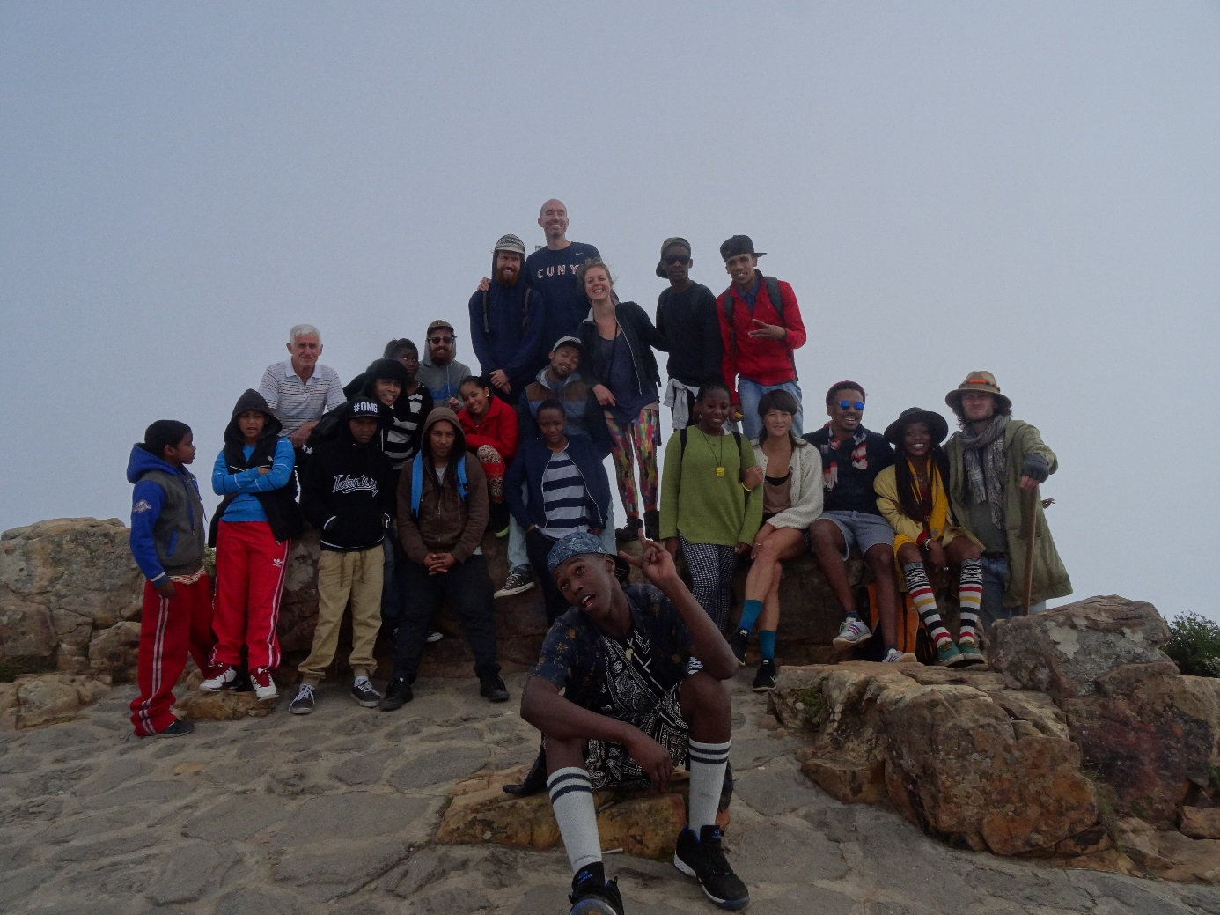
After our journey

As we update this policy plan, we have returned from our journey over 6 months ago. The phase our foundation is currently in askes for a separate paragraph in this policy plan. In2Afrika is still strategically employing a binary approach, with two objectives that go hand in hand:

Active support to the projects
From the Netherlands, In2Afrika will be an active partner for the projects. The intensity and the shape in which the partnership will take place, differs per project. In our Letter of Intent, published in august of 2015 on our website, a more detailed description of every partnership can be found.

Imagery
Remains essential even after our journey. On the one hand, specific projects and the way we partner with them will be put in the spotlight as a way to recreate the image of how Africa is evolving. On the other hand more general content will be put out to recreate the currently existing image of the African continent. On a smaller scale we will publish and share relevant articles and imagery. On a bigger scale the publishing of a book with a collection of interesting images and stories of the continent is one of the main ambitions for the upcoming period.

For additional information besides this policy plan, please also see our Letter of Intent published in July 2015, via: http://www.in2afrika.nl/#!nieuws/c838

